CSA1509-Cloud computing and Big Data Analytics
Name : DHARSHANA SIVAKUMAR
Reg.no: 192511054

EXP 13 : Create a Virtual Machine with 1 CPU, 2GB RAM and 15GB storage disk using a Type 2 Virtualization Software.Aim:
To Create a Virtual Machine with 1 CPU, 2GB RAM and 15GB storage disk .
Steps:
- Download VMware software and install it as Type-2 Hypervisor.
- Download Ubuntu or tiny os as ISO image file.
- In VMware workstation Create new VM
- Do the configuration based on given conditions.
  - Change number of processors to 1.
  - Change Memory to 2 GB and storage to 15 GB.
- Created a virtual Machine .
- Launch the VM.
Implementation:
- Download and open VMware software.
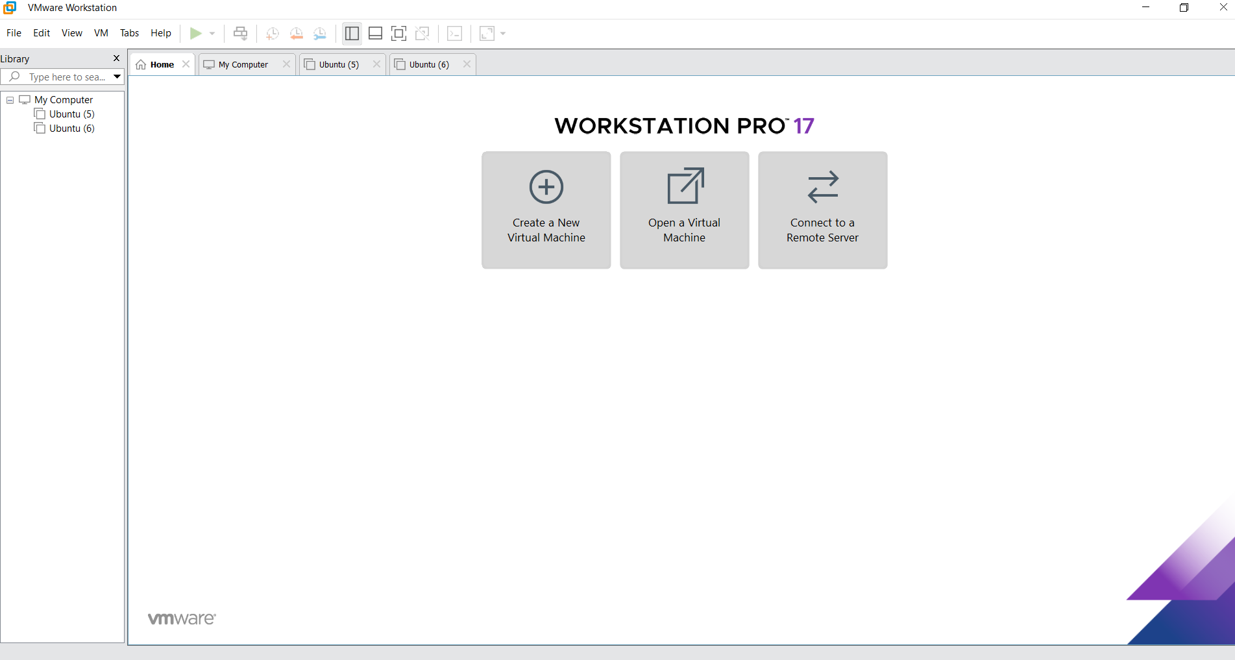
2.Create a new VM

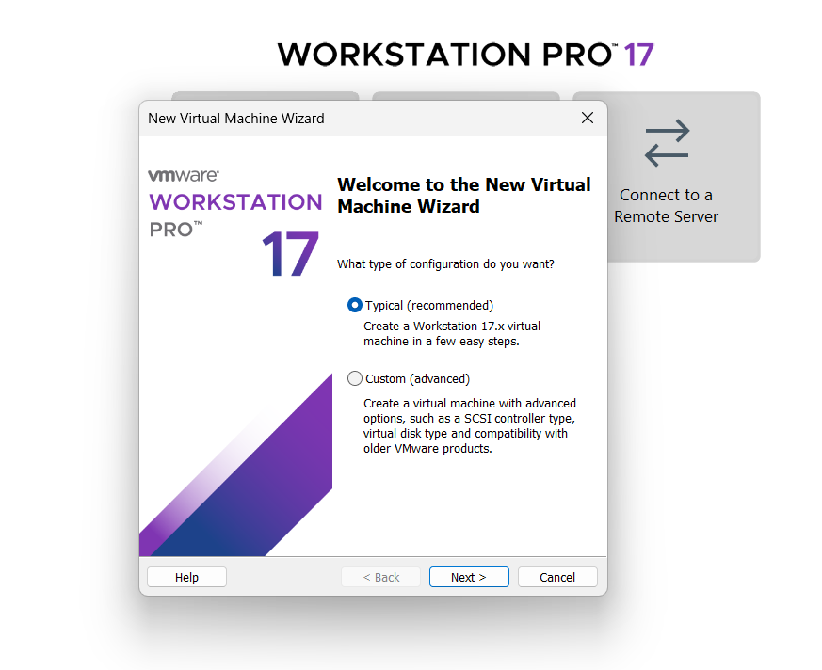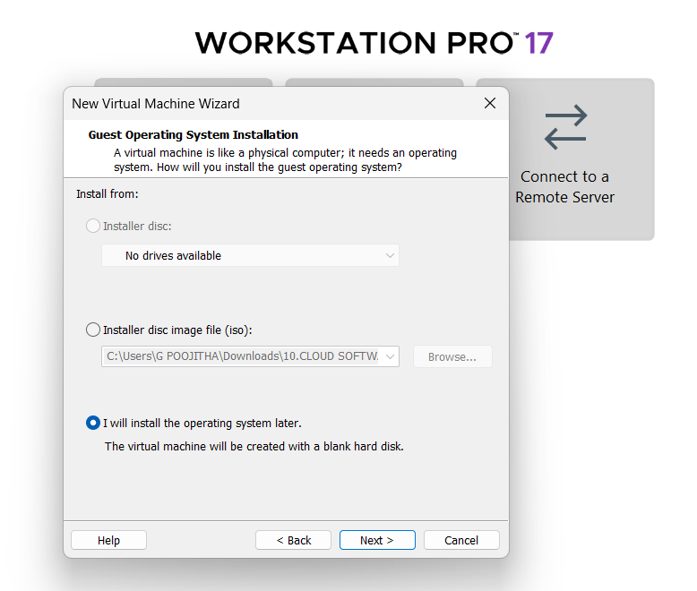
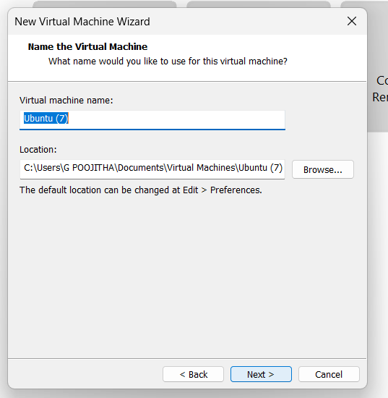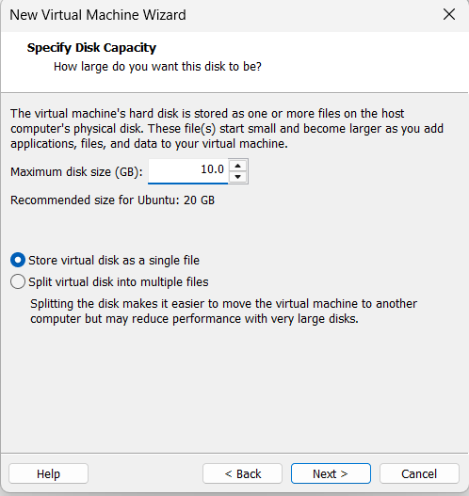
Name it anythingclick on nextAdjust the size of disk change the option to first and then click on next.
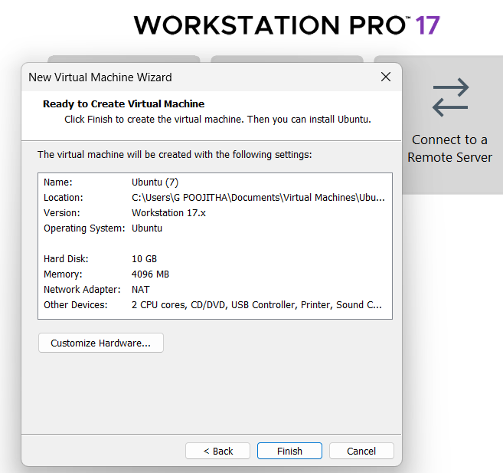 Click on Finish to Launch .

3.VM is created
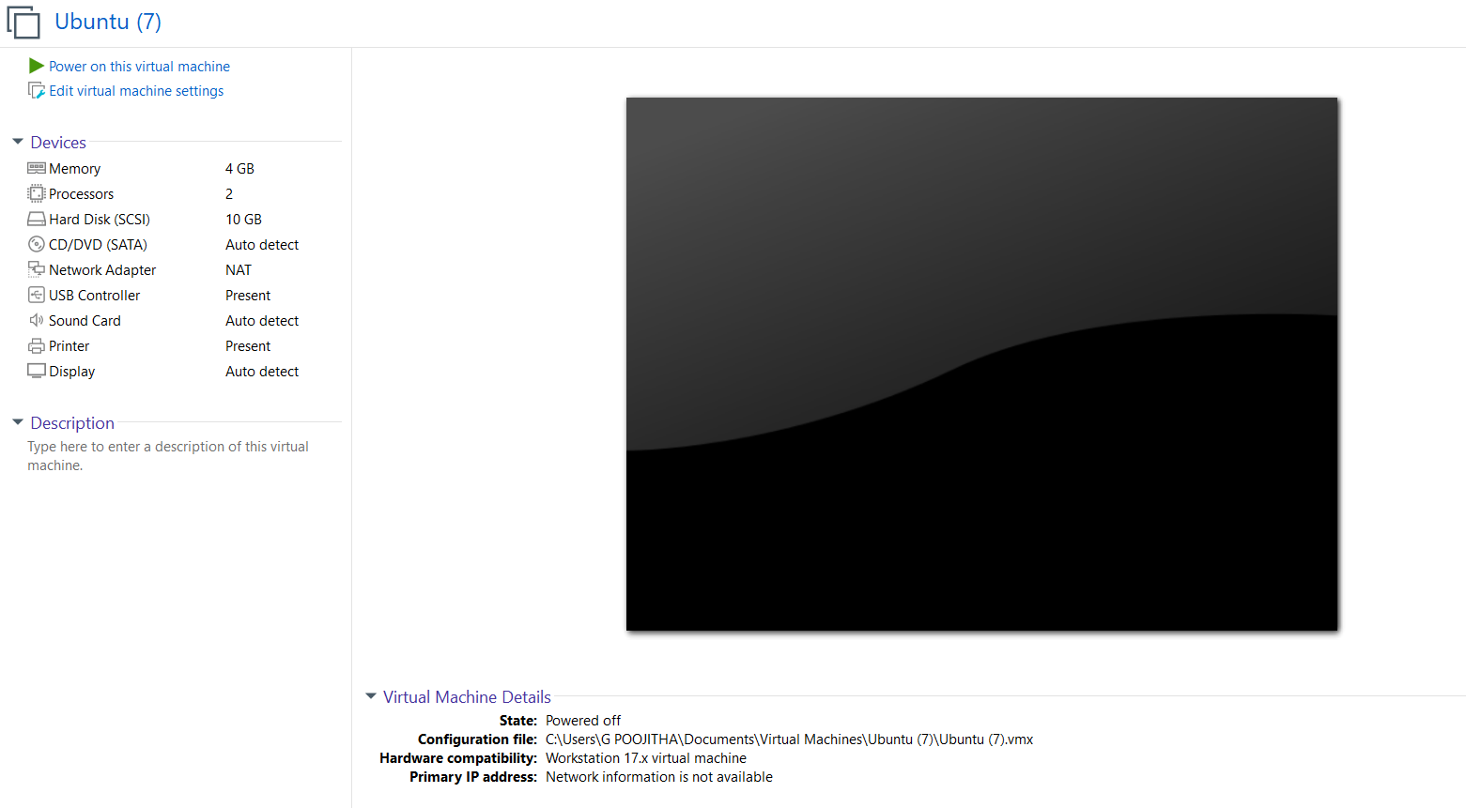
4. Double-click on processors and Change number of Processors.
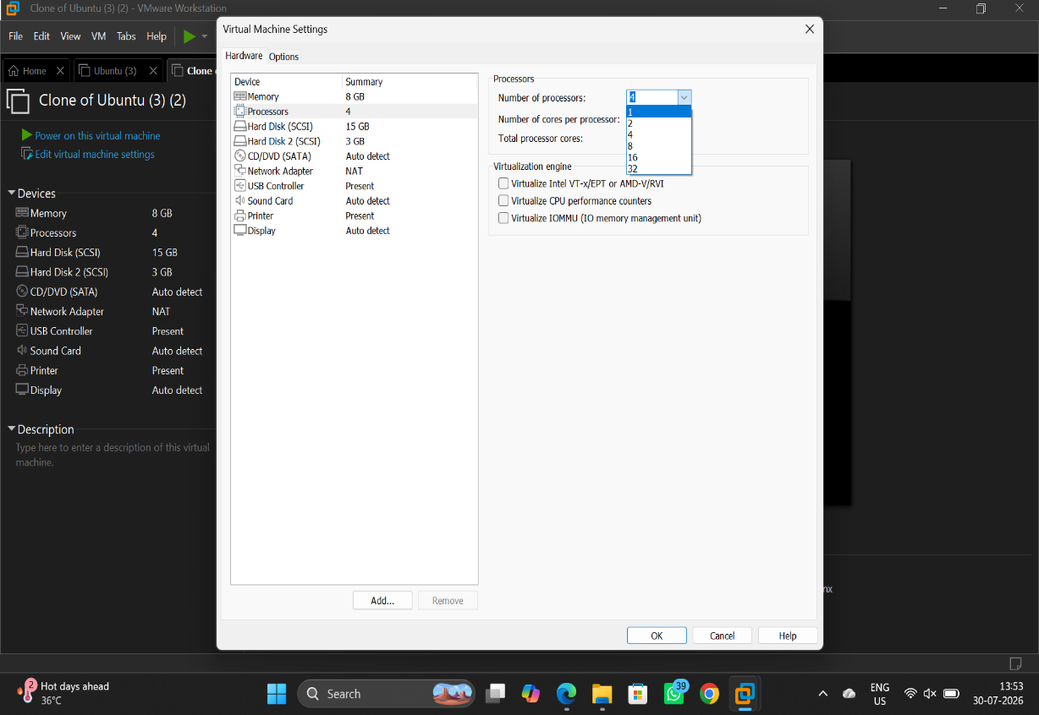

5. Click on hard disk and Change storage of hard disk.
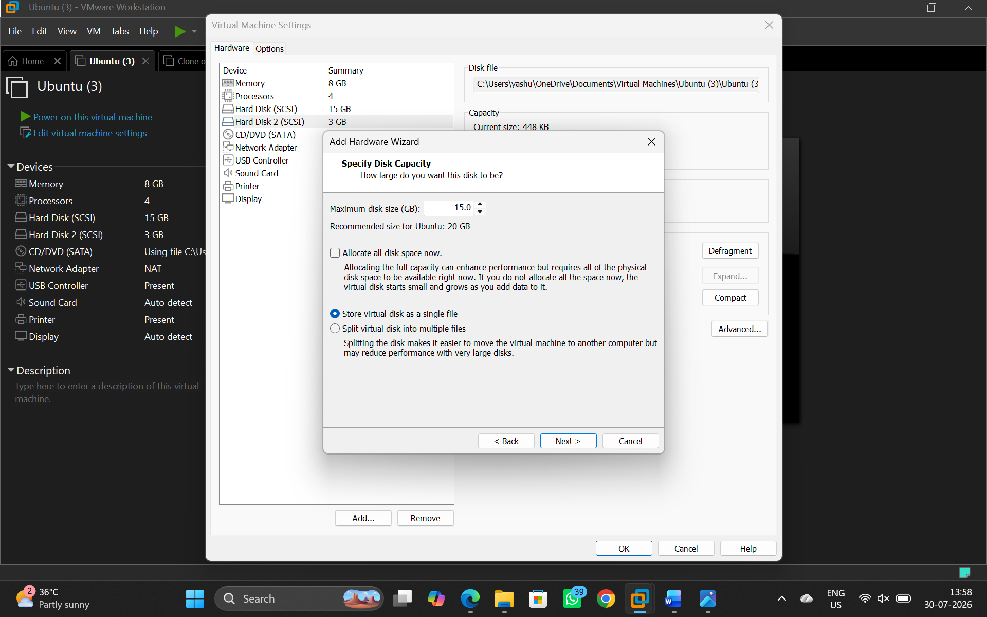

5. Click on memory and change size of the memory
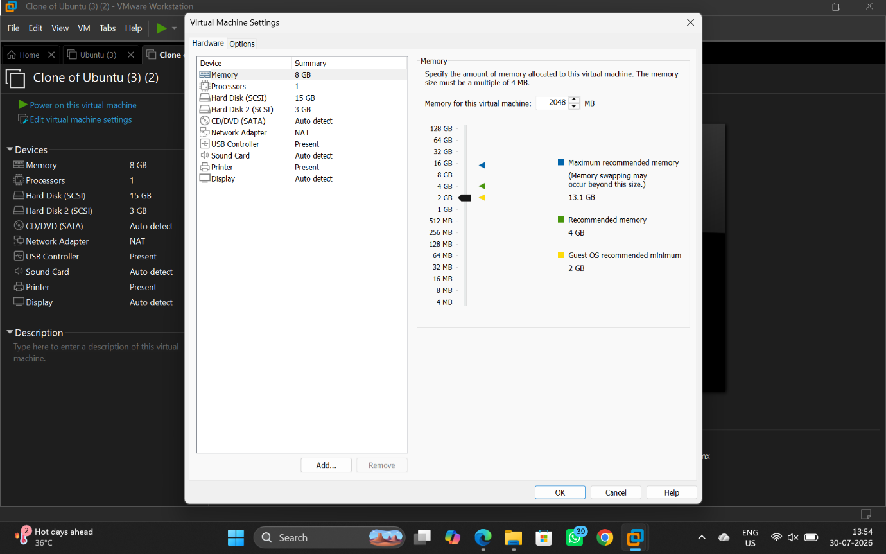

6. VM is created according to the conditions given.
